***AEC* *LAB REPORT – 7***

***Common Source Amplifier***

***NAME:*** *Khyathi Sri Basireddy*

***ROLL NO****: 2023102065*

***TABLE NO: 9***

***1.*** ***Effect of Body Effect on Gain of CS Amplifier***

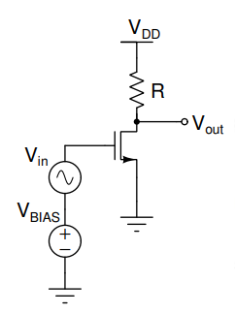

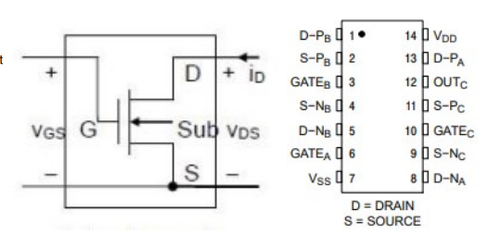

***Input Parameters:***

Vdd = 5V

VBIAS = 2.5V

VT = 1.8V

RL = 4.7k ohm

***(a) DC Analysis***

* Value of DC value of VDS = 3.3V (measured using multimeter)

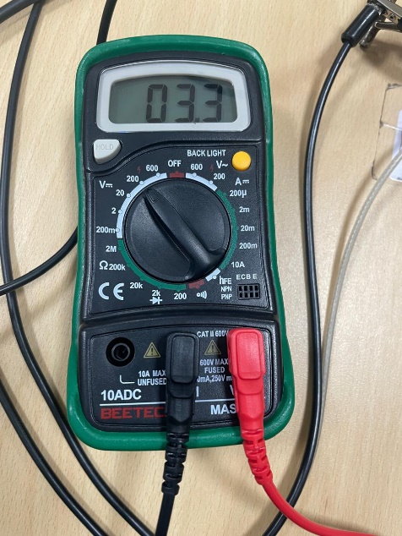

* VBIAS – VT = 0.7V < VDS

Hence, MOSFET is in saturation region.

* **Drain Current**

IDS = (VDD – VDS)/ RL

= 5 – 3.3 / 4.7k

IDS = 361.70 uA

* **µnCOX(W/L)**

µnCOX(W/L) (VGS -VT)2= IDS

µnCOX(W/L) (2.5 -1.8)2 =361.70 *10-6

µnCOX(W/L) = 738.16 uA/V2

* **Transconductance**

gm = µnCOX(W/L) (VGS -VT)

= 738.16 (2.5 -1.8)

gm = 516.71 micro-ohm-1

***(b)AC Signal***

**Input Parameters:**

Vpp = 50 mV

f = 1 kHz

Offset = 2.5V (for giving VBIAS)

Gain, AV = VOUT/VIN = gm. RL

* **Gain Calculated**, AV = gm. RL

= (516.71) x 4.7k

= 2.42

* **Gain Experimental**, AV = VOUT/VIN

= 165 mV / 60 mV

= 2.75

The calculated and experimental gain are almost close. Yes, it matches closely.

* **gm effective**

gm = Gain (experimental) / RL

= 2.75 / 4.7k

= 585.11 micro-ohm-1

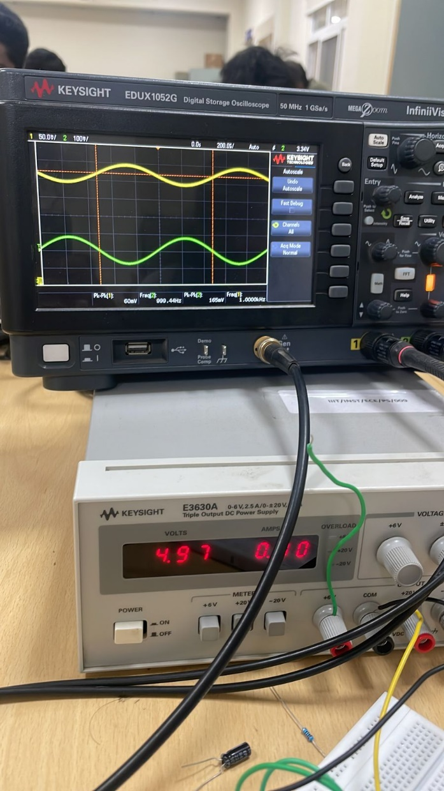

***(c)Body Effect***

* Connect the body to the dc supply



|  |  |  |  |
| --- | --- | --- | --- |
| **Body Voltage (VSS)** | **Vout** | **Gain** | **gm(effective)** |
| 0 | 165 mV | 2.75 | 585.10 micro-ohm-1 |
| 0.4 | 209 mV | 3.48 | 741.13 micro-ohm-1 |
| -0.4 | 109 mV | 1.81 | 386.52 micro-ohm-1 |

**VSS = -0.4V**

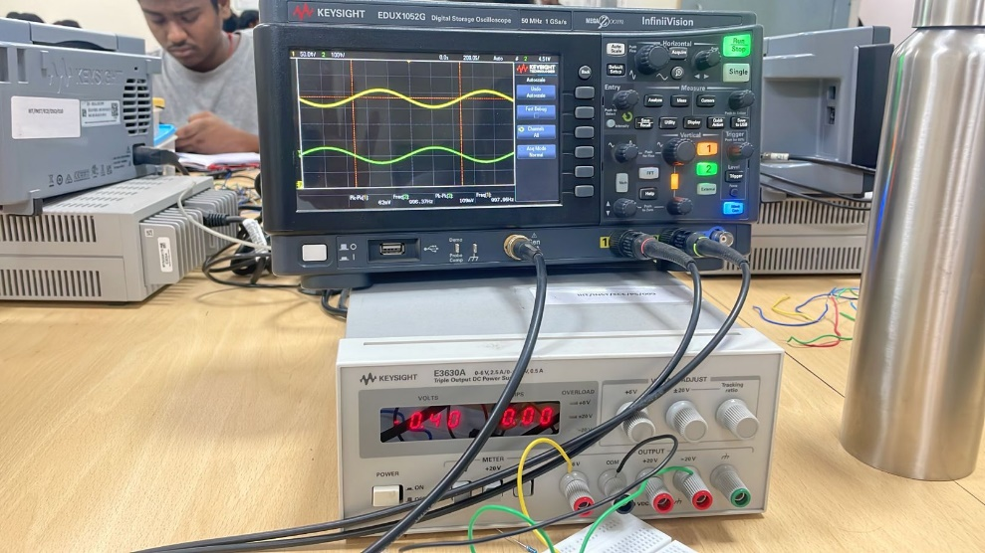

**VSS = 0V**

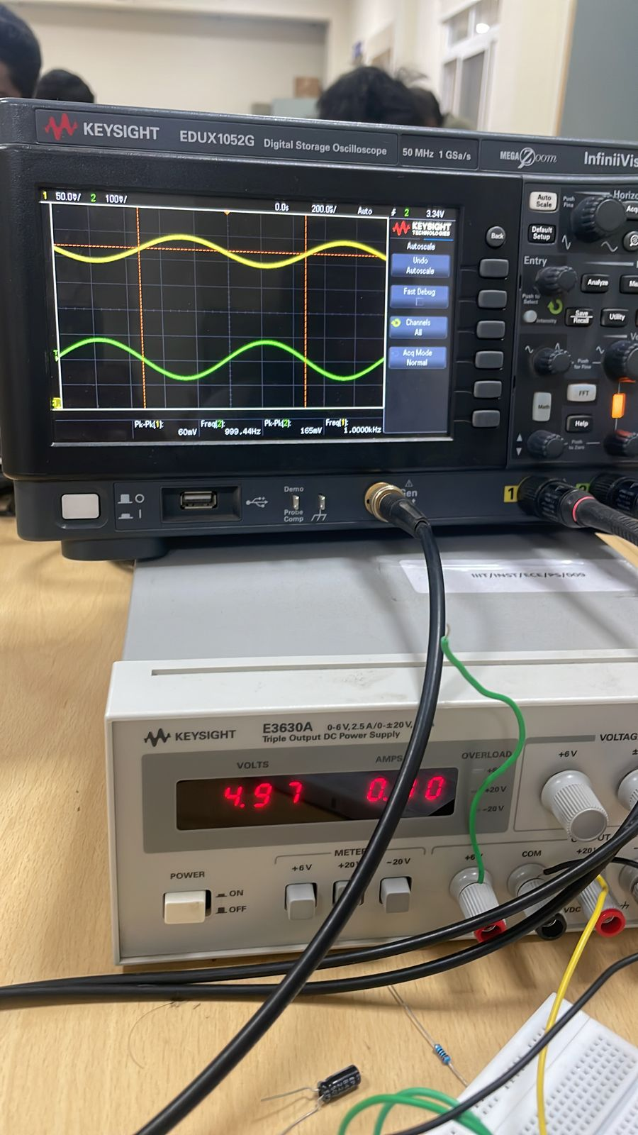

**VSS = 0.4 V**

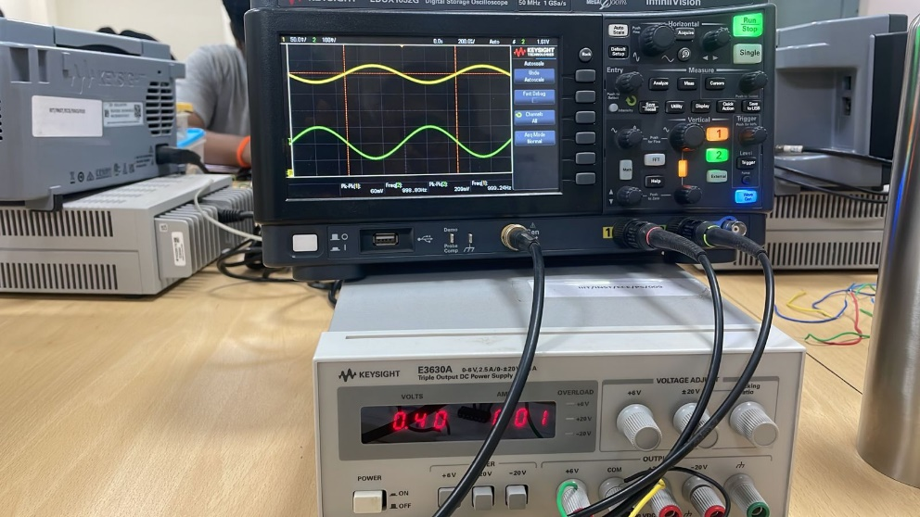

**Comments on effect of Body Effect:**

An NMOS (n-channel MOSFET) experiences an increase in channel conductivity as the body voltage is raised. The potential of the p-substrate increases as the body voltage rises.   
  
More electrons are drawn out of the n+ areas of the substrate due to positive charge accumulation at the substrate's bottom. As a result, to enable conduction and fill the channel with electrons, a lower threshold voltage (VT) is needed.   
An increase in transconductance (gm) is seen because it is directly proportional to the difference between the gate-to-source voltage (VGS) and the threshold voltage (VT). This is due to the fact that a bigger VGS-VT value, which is produced by a lower VT, results in higher conductance.

Conversely, the n+ regions and the p-substrate are in reverse bias if the body voltage is lowered (VBS < 0). The raised threshold voltage is the result of pushing electrons farther into the n+ regions by this reverse biasing. As a result, a greater Vth is required to allow conduction and fill the channel with electrons, which lowers transconductance (gm).

***2.Effect of BIAS points on Gain of Common Source Amplifier***

**(a) Input Parameters:**

For VIN

Vpp = 50 mV

f = 1 kHz

Offset = 0V

**(d) Table:**

We begin to vary BIAS voltage, and obtain different values of VOUT and gain.

The tabulated values are given below,

|  |  |  |  |
| --- | --- | --- | --- |
| **VBIAS** | **VOUT** | **GAIN** | **gm** |
| 1.5 | 5.06 | 0.212 | 45.1 micro-ohm-1 |
| 1.8 | 4.94 | 0.74 | 157.44 micro-ohm-1 |
| 2.5 | 3.84 | 2.55 | 542.55 micro-ohm-1 |
| 3.1 | 1.846 | 3.80 | 808.51 micro-ohm-1 |
| 4 | 0.518 | 0.318 | 65.95 micro-ohm-1 |

**VBIAS = 1.5V**

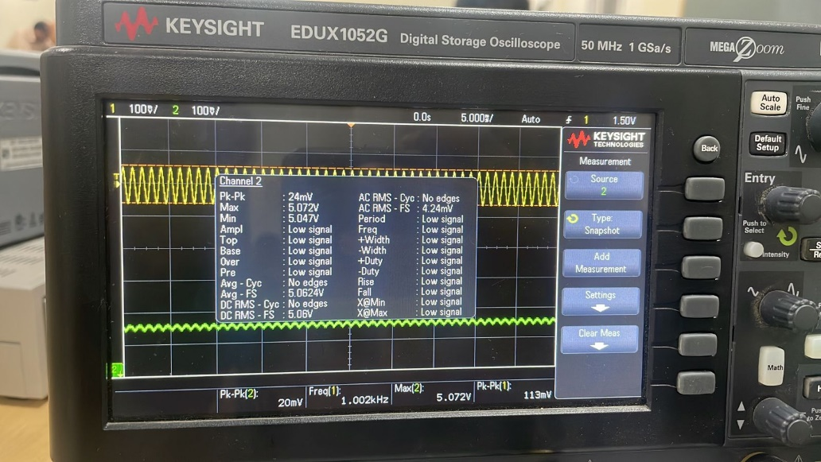

**VBIAS = 1.8V**

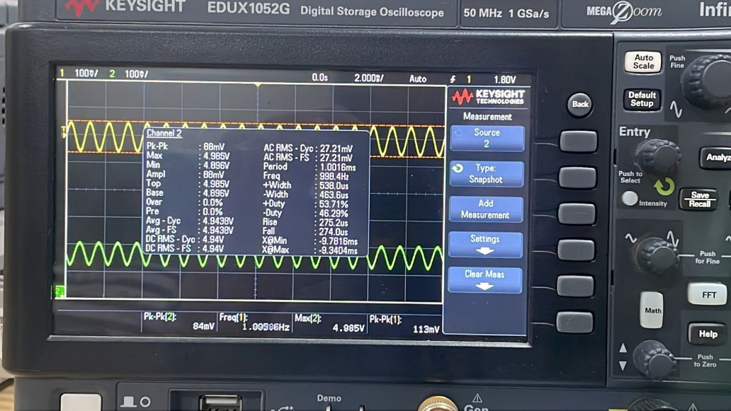

**VBIAS = 2.5V**

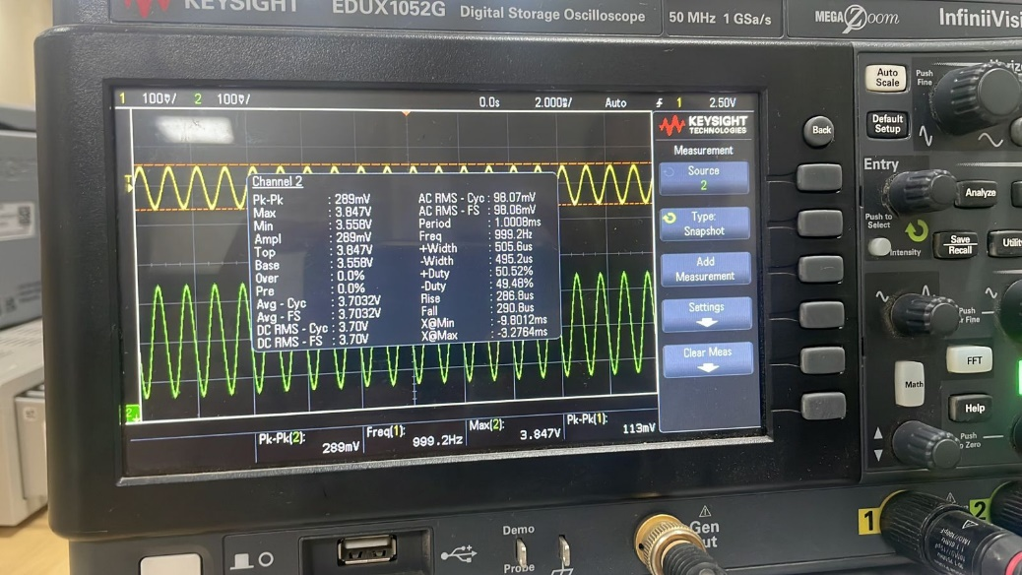

**VBIAS = 3.1V**

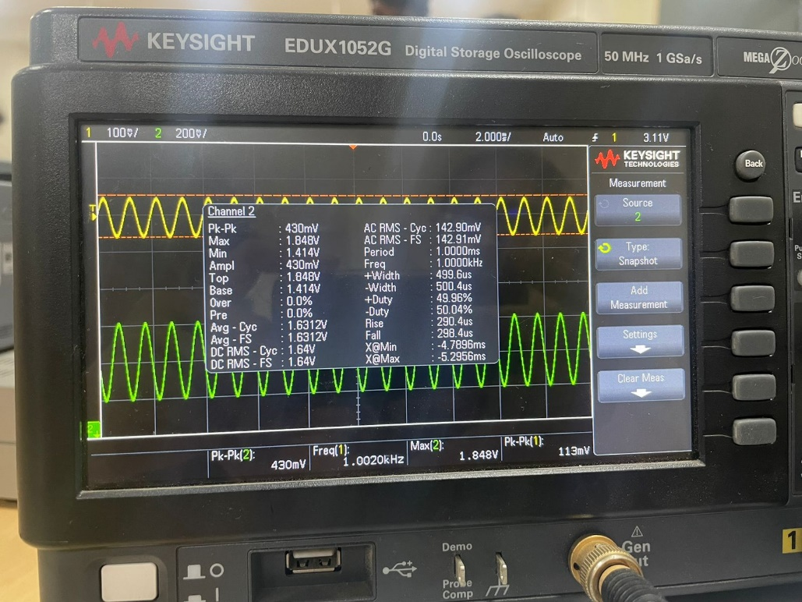

**VBIAS = 4V**

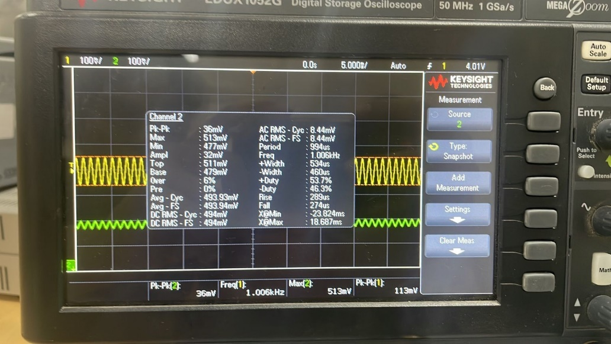

**(c) Plot of gm vs VGS**

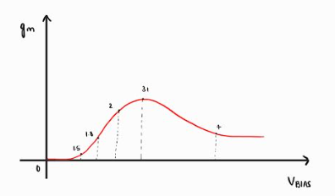

***3.Effect of small input signal on gain of common source amplifier***

**(a) Input Parameters:**

VBIAS = 2.5V

**For VIN**

Vpp = 100 mV

f = 1 kHz

Offset = 0V

**Step Size = 100 mV**

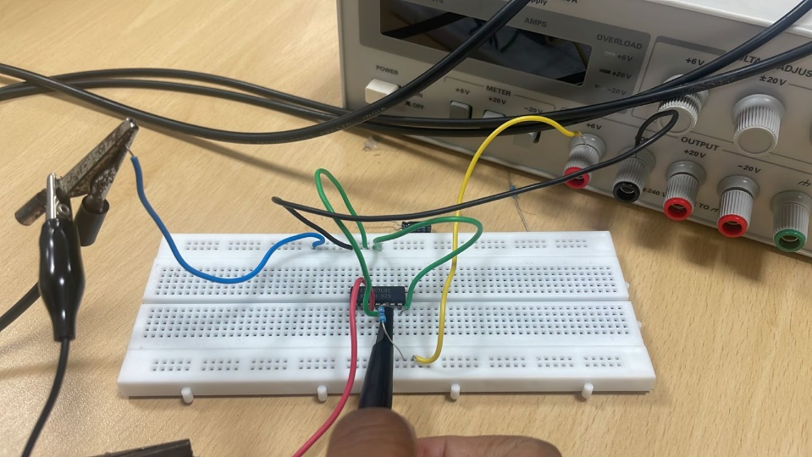

**(b) Table:**

|  |  |  |  |
| --- | --- | --- | --- |
| **VIN** | **VOUT** | **GAIN** | **gm** |
| 117 mV | 289 mV | 2.47 | 525.53 micro-ohm-1 |
| 213 mV | 590 mV | 2.76 | 589.35 micro-ohm-1 |
| 330 mV | 900 mV | 2.827 | 580.21 micro-ohm-1 |
| 430 mV | 1.19 mV | 2.767 | 588.83 micro-ohm-1 |
| 540 mV | 1.47 mV | 2.722 | 579.19 micro-ohm-1 |
| 660 mV | 1.71 mV | 2.59 | 551.25 micro-ohm-1 |
| 780 mV | 2.01 mV | 2.57 | 546.80 micro-ohm-1 |
| 880 mV | 2.25 mV | 2.5568 | 544.00 micro-ohm-1 |
| 1.05 mV | 2.390 mV | 2.390 | 508.61 micro-ohm-1 |
| 1.3 mV | 3.04 mV | 2.33 | 497.54 micro-ohm-1 |
| 1.5 mV | 5.04 mV | 2.28 | 485.10 micro-ohm-1 |
| 1.69 mV | 4.3 mV | 2.24 | 476.59 micro-ohm-1 |

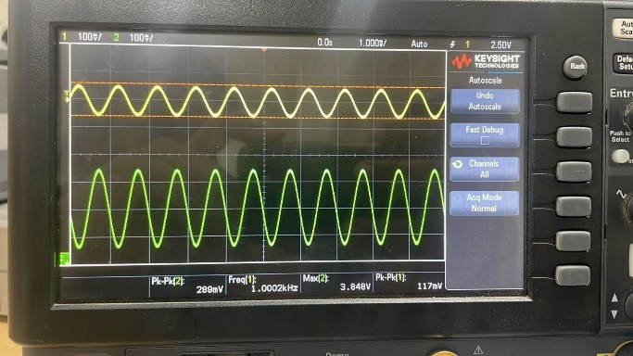 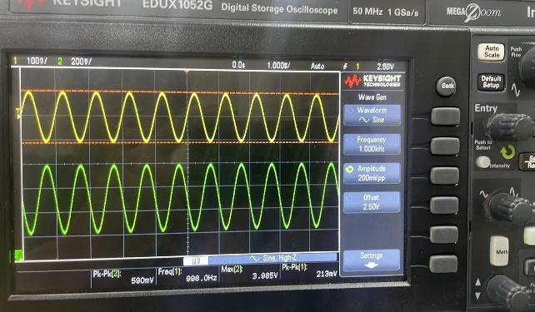

**VIN = 100mV VIN = 200mV**

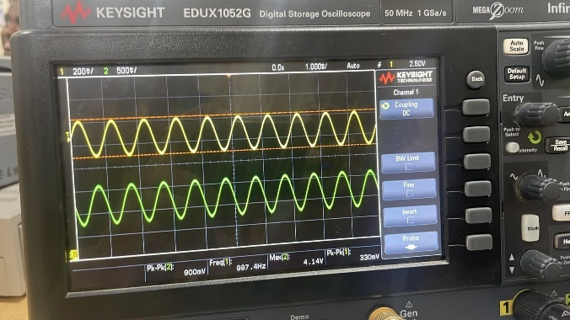 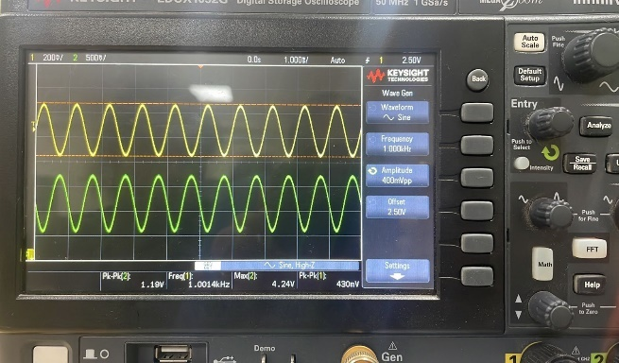

**VIN = 300mV VIN = 400mV**

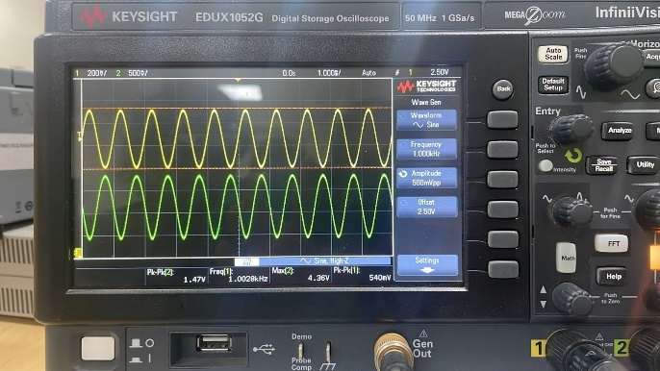 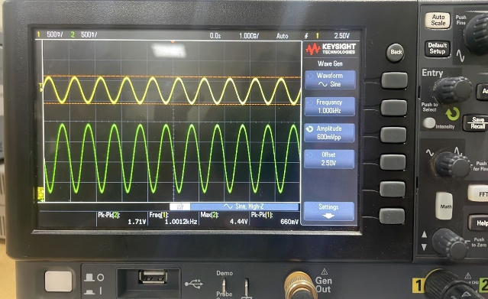

**VIN = 500mV VIN = 600mV**

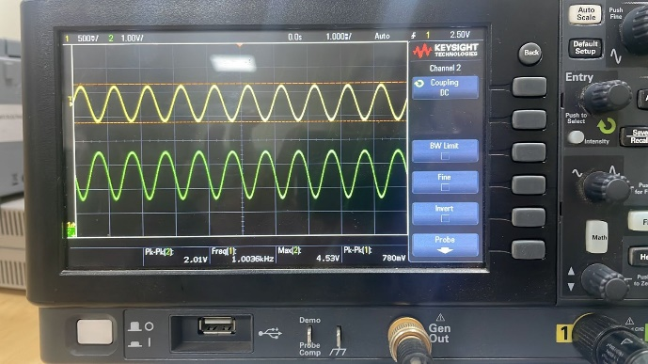 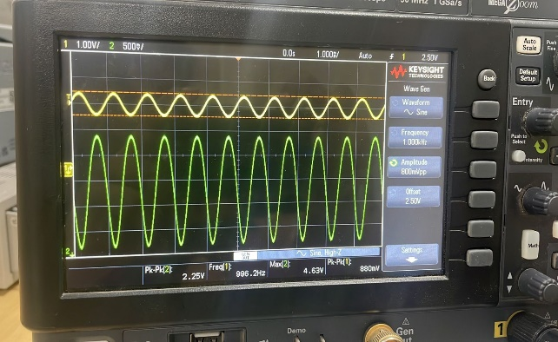

**VIN = 700mV VIN = 800mV**

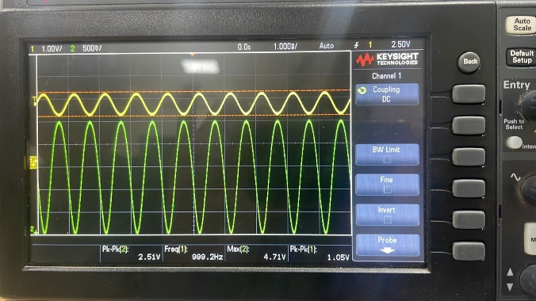 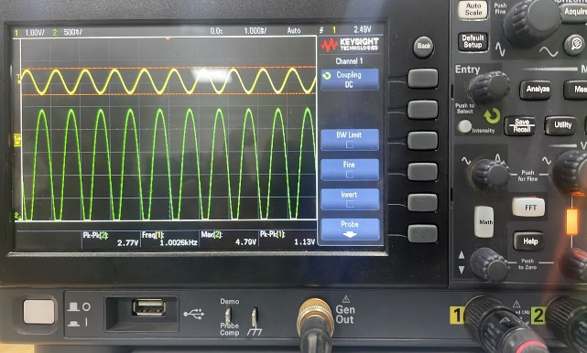

**VIN = 900mV VIN = 1V**

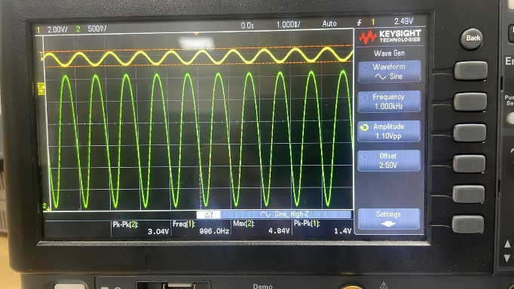 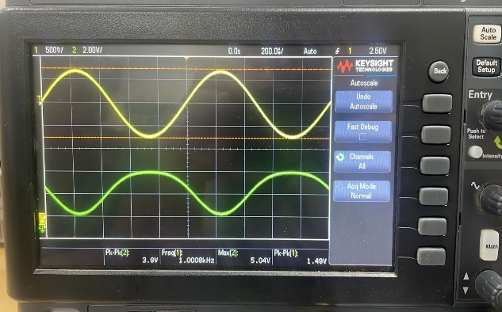

**VIN = 1.1V VIN = 1.4V**

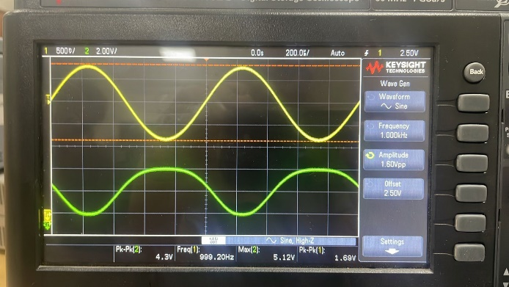

**VIN = 1.6V**

**The above graph clearly shows that clipping of the circuit has started.**

**(c)Reason for Clipping**

When the input voltage crosses a certain threshold in a common source amplifier configuration, output voltage clipping occurs. The primary cause of this phenomenon is the inherent limitations connected to the MOSFET's operational features.   
When operating in the saturation region, a particular voltage range, the MOSFET displays desirable amplification properties. But the MOSFET enters the triode, or cutoff, region when the input voltage rises above a certain point, at which point it is unable to provide the required amplification.   
The MOSFET functions as a switch during the cutoff region, essentially stopping the current flow through the device. As a result, the output voltage is limited to a particular value that is often referred to as the clipping or saturation voltage.

To put it briefly, linearity is only maintained up to VGS exceeding VT, even though the gain increases steadily with increasing VGS in the saturation region. When VGS is less than Vth, the output signal loses linearity on the negative side due to an increase in gain accompanied by clipping.

***4.CS Amplifier with external coupling***

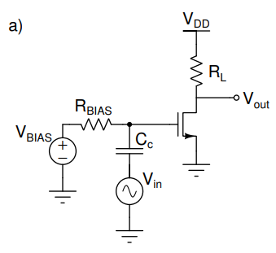

**(a) Input Parameters:**

VBIAS = 2.5V

VDD = 5V

RL = 4.7k ohm

RBIAS = 100 ohm

CC = 10 uF

**For VIN**

Vpp = 100 mV

f = 1 kHz

Offset = 0V

**(b) Gain and gm**

VOUT = 210 mV

VIN = 90 mV

**AV, Gain = VOUT / Vin**

= 210 / 90

= 2.33

**gm = Gain / RL**

= 2.33 / 4.7k

= 496.45 micro-ohm-1

The value of gm in the previous problem is approximately 516.71 micro-ohm-1 which almost close to the value obtained now.

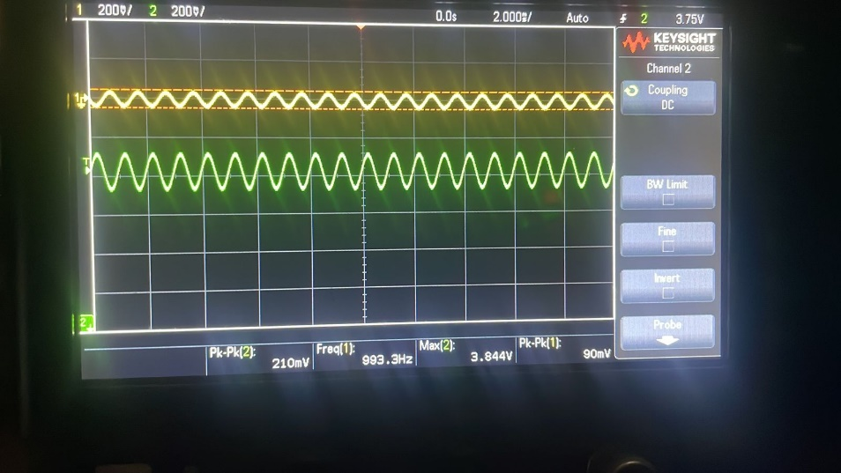

**(c)VDS, IDS and µCox W/L** **calculations**

* **Drain Voltage**

VDS = 3.41 V (measured using multi meter)

* **Drain Current**

IDS = (VDD – VDS)/ RL

= 5 – 3.41 / 4.7k

IDS = 338.29 micro-A

* **µnCOX(W/L)**

µnCOX(W/L) (VGS -VT)2= IDS

µnCOX(W/L) (2.5 -1.8)2 = 338.29 *10-6

µnCOX(W/L) = 690.4038 micro- A/V2

**(d)With Load Capacitor, CL**

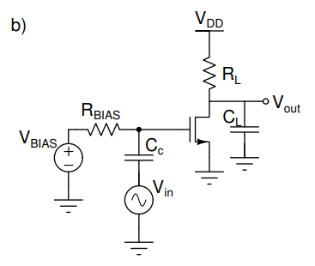

CL = 470 pF

**Frequency Response Analysis:**

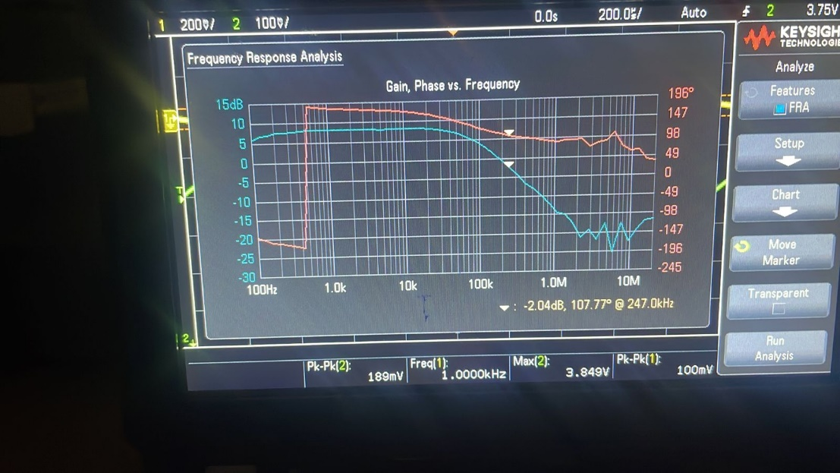

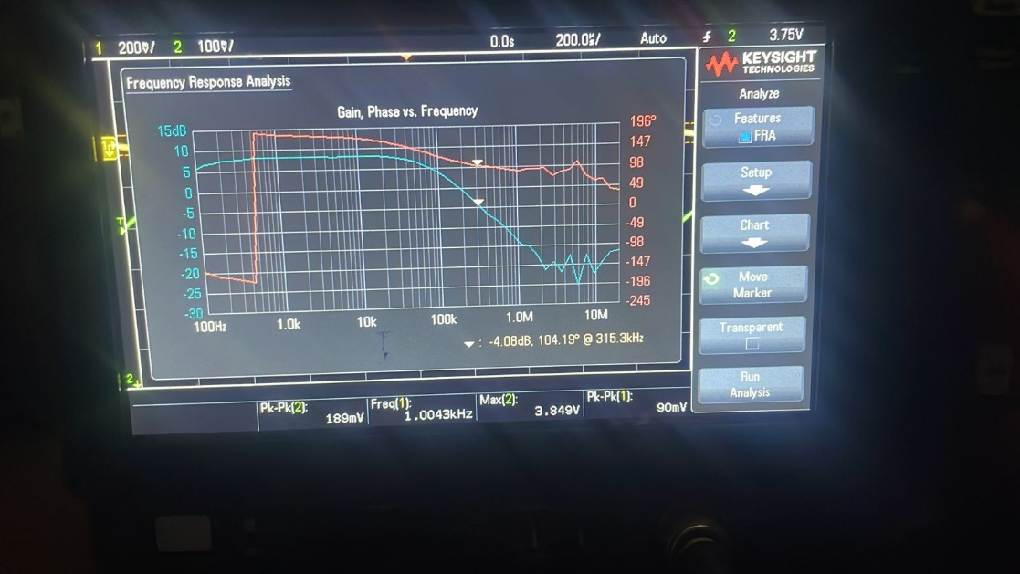

At -2.04 dB, the frequency is 247.0 kHz

At -4.08 dB, the frequency is 315.3 kHz

To find the -3dB bandwidth, take the average of above two.

-3 dB Bandwidth = 281.15 kHz

**Estimated Poles of the Transfer Function:**

